**:Assignment -1:**

**Source Code:**

# #BAR CHART

import matplotlib.pyplot as plt import pandas as pd # Sample data data = {

'Branch': ['A', 'B', 'C'],

'Rating': [4.5, 4.2, 4.6],

'Gender': ['Male', 'Female', 'Others'],

'Total': [50000, 70000, 60000],

'City': ['Yangon', 'Mandalay', 'Naypyitaw']

}

# Convert data to DataFrame df = pd.DataFrame(data) # Plotting the bar chart plt.figure(figsize=(10, 6)) plt.bar(df['City'], df['Total'], color='yellow') plt.xlabel('City') plt.ylabel('Total Sales') plt.title('Total Sales by City') plt.grid(axis='y', linestyle='--', alpha=0.7) plt.tight_layout() plt.show()

**OUTPUT :**

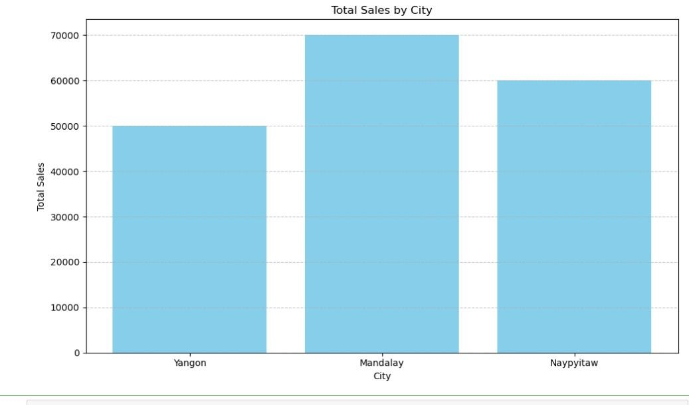

**Source Code:**

# #PIE CHART

import pandas as pd import matplotlib.pyplot as plt

# Sample data for the supermarket data = {

'Product line': [ 'Health and beauty', 'Electronic accessories', 'Food and beverages', 'Home and lifestyle'],

'gross income': [15000, 10000, 8000, 5000]

}

# Create a DataFrame df = pd.DataFrame(data)

# Create a pie chart

plt.figure(figsize=(8, 8))

plt.pie(df['gross income'], labels=df['Product line'], autopct='%1.1f%%', startangle=140)

plt.axis('equal') # Equal aspect ratio ensures that pie is drawn as a circle.

plt.title('Supermarket Sales by Category') # Display the pie chart plt.show()

**OUTPUT:**

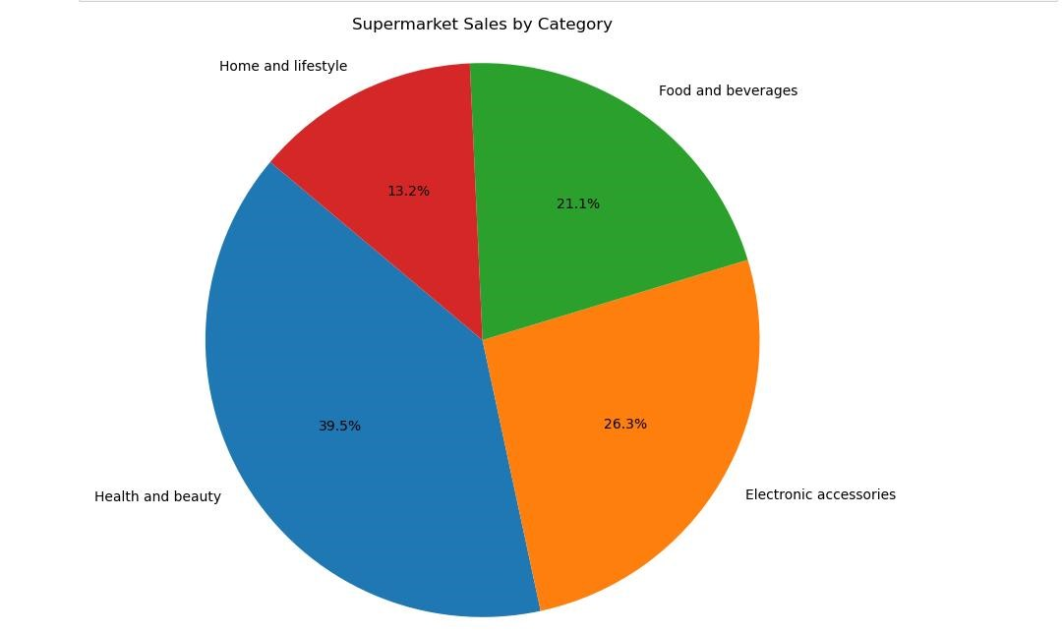

**Source Code:**

# #Stacked Bar Chart

import matplotlib.pyplot as plt import pandas as pd # Sample data data = {

'Branch': ['A', ' B', ' C'],

'Total': [30000, 40000, 35000],

'Rating': [20000, 30000, 25000],

}

# Convert data to DataFrame df = pd.DataFrame(data) # Plotting the stacked bar chart plt.figure(figsize=(10, 6))

# Plotting the bars for male total sales

plt.bar(df['Branch'], df['Total'], color='skyblue', label='Male') # Plotting the bars for female total sales on top of male total sales plt.bar(df['Branch'], df['Rating'], bottom=df['Total'], color='pink', label='Female') plt.xlabel('Branch') plt.ylabel('Total Sales') plt.title('Total Sales by Branch and Gender') plt.legend()

plt.grid(True, linestyle='--', alpha=0.7) plt.tight_layout() plt.show()

**OUTPUT:**

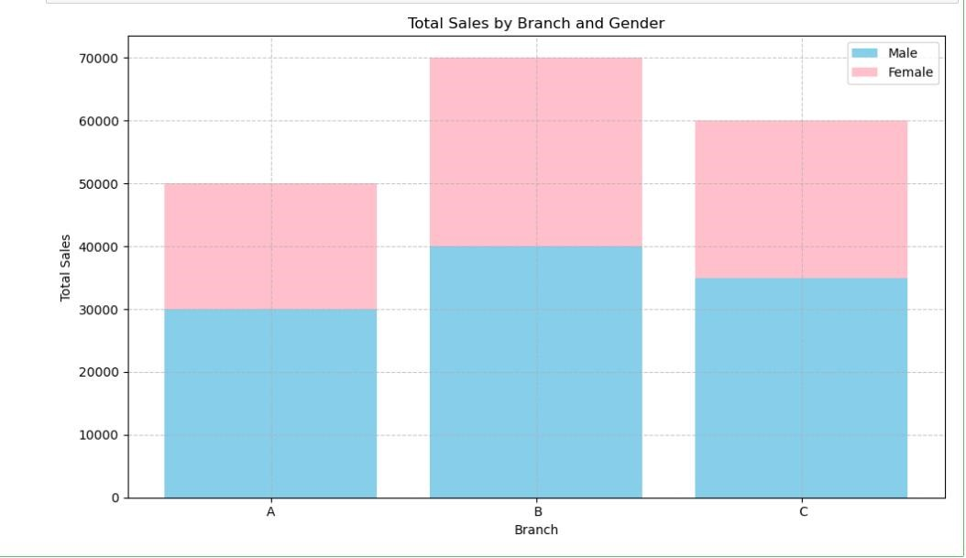

**Source Code:**

# #LINE CHART

import matplotlib.pyplot as plt import pandas as pd # Sample data data = {

'Branch': ['A', ' B', 'C'],

'Rating': [4.5, 4.2, 4.6],

'Gender': ['Male', 'Female', 'Others'],

'Total': [50000, 70000, 60000],

'City': ['Yangon', 'Mandalay', 'Naypyitaw']

}

# Convert data to DataFrame df = pd.DataFrame(data) # Plotting the line chart plt.figure(figsize=(10, 6))

plt.plot(df['Gender'], df['Total'], marker='o', color='skyblue', linestyle='-') plt.xlabel('Gender') plt.ylabel('Total Sales') plt.title('Total Sales by Gender') plt.xticks(rotation=1) plt.grid(True, linestyle='--', alpha=0.7) plt.tight_layout() plt.show()

**OUTPUT:**

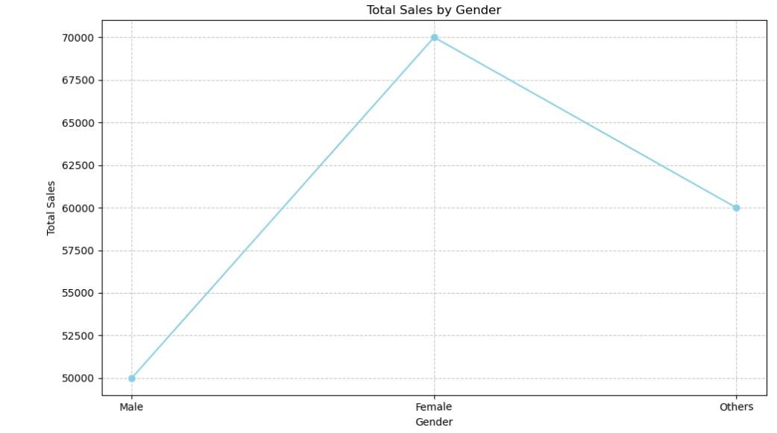

**Source code:**

# #Bubble Chart

import matplotlib.pyplot as plt import pandas as pd # Sample data data = {

'Branch': ['A', 'B', 'C'],

'Rating': [4.5, 4.2, 4.6],

'Gender': ['Male', 'Female', 'Others'],

'Total': [50000, 70000, 60000],

'City': ['Yangon', 'Mandalay', 'Naypyitaw']

}

# Convert data to DataFrame df = pd.DataFrame(data) # Plotting the bubble chart plt.figure(figsize=(10, 6))

plt.scatter(df['Branch'], df['Rating'], s=df['Total']/1000, alpha=0.5, c='skyblue', edgecolors='k', linewidth=1) plt.xlabel('Branch') plt.ylabel('Rating')

plt.title('Bubble Chart of Rating by Branch (Total Sales)') plt.xticks(rotation=3) plt.grid(True, linestyle='--', alpha=0.7) plt.tight_layout() plt.show()

**OUTPUT:**

